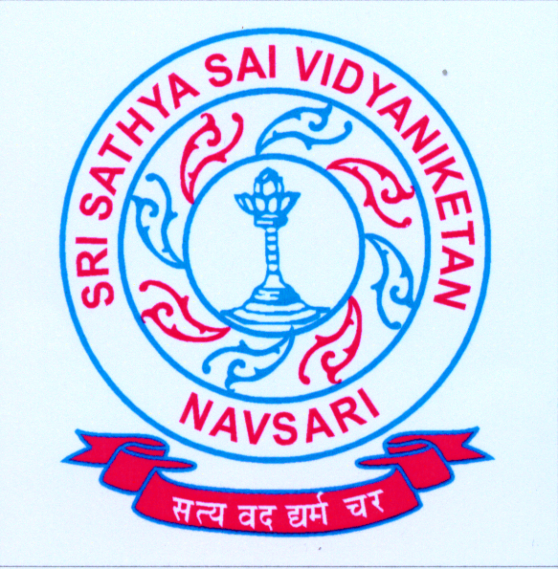

SRI SATHYA SAI VIDYANIKETAN
GANESHVAD SISODRA, NEAR TATA SSL
NAVSARI , PH: (02637) 291030,M:- 9601261085
CBSE AFFILIATION NO: 430102
E-MAIL: sssvn_navsari@yahoo.in
www.sssvn.edu.in

Are you looking for a dynamic Career in Teaching? | Apply Now!
A renowned fully residential CBSE school requires Educators & Support Staff

PGT (Chemistry, Maths): M.Sc. with B.Ed.
TGT (English, Sanskrit, Hindi, Science): M.Sc./B.Sc. /M.A/B.A with B.Ed. & TAT/CTET
PRT (English, Art & Craft): MA/BA/B.com with B.Ed. and TAT/CTET /MA in fine Arts
Counsellor: MA in psychology and Diploma in Counseling and Guidance
Nurse: B.Sc. Nursing
Librarian: M.Lib with 2 years’ experience
Lab Assistant: B.Sc.
IT coordinator: MCA/M.Sc. IT/BE/BTech in IT
Minimum 3years CBSE experienced, working candidates studied throughout English Medium will be preferred for Teaching positions. Eligible candidate can walk in interview on 20/02/2017 Monday at 9:00 am with full handwritten Bio data & original certificate on above address.
NB: Forward one set of scanned copy of complete bio data along with photograph latest by 04/02/2017 by e-mail. sssvn_navsari@yahoo.in.
Principal

