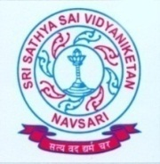
SRI SATHYA SAI VIDYANIKETAN
(CBSE affiliated, English Medium, Fully Residential School)
Near TATA SSL, N.H. 8, Ganeshvad Sisodra, Navsari – 396 463.
Phone: (02637) 291030, 09601261085
Visit: www.sssvn.edu.in, E-mail: sssvn_navsari@yahoo.in

Standard –III & XI (Science, Commerce) for both Boys and Girls for the Academic Session 2017–18.
Application form along with prospectus will be available in office on payment of Rs. 300/- from 13th February 2017 to 20th February 2017 during school hours (10:00 am. to 05:00 pm). The last date of submission of completed application form is 20th February 2017.

Note: Application form can also be obtained by post. Please send DD Rs. 350/- in favour of “Vidyaniketan Hostel” payable at Navsari.

